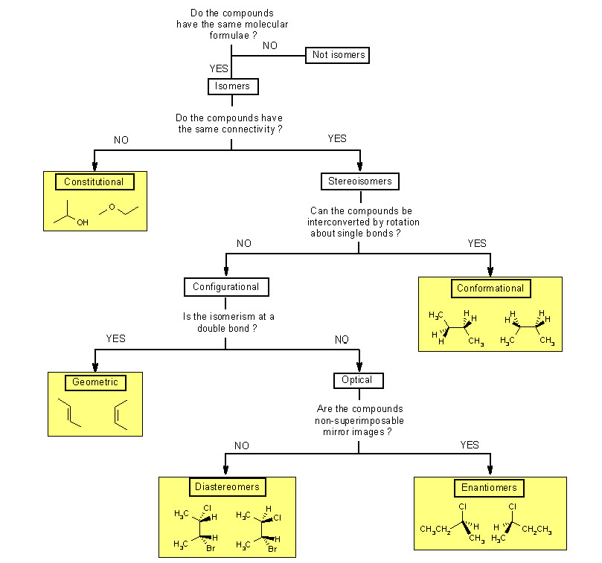

Structural Isomers

* Share only a molecular formula
* Have different physical and chemical properties

Stereoisomers

1. **Conformational** isomers
   1. Differ by rotation around a single (σ) bond
   2. Two types of conformations (Newman projection)
      1. Staggered conformation → anti (180o), gauche (60o)
      2. Eclipsed conformation → eclipsed (120o), totally eclipsed (0o)
   3. Strain in cyclic molecules
      1. Angle (deviating from normal angles)
      2. Torsional (from eclipsing conformations)
      3. Nonbonded (interactions b/w substituents attached to nonadjacent carbons) → Cyclohexane: Largest substituent take equatorial (in the plane of molecule)
2. **Configurational** isomers
   1. Interchanged by breaking and reforming bonds
   2. **Enantiomers** (optical activity) - mirror-image stereoisomers
      1. Dextrorotatory (d) or (+)
      2. Levorotatory (l) or (-)
   3. **Racemic** mixtures = equal amounts of enantiomers (no optical activity)
   4. **Meso-compound** → internal plane of symmetry; no optimal activity despite chiral centres
   5. **Diastereomers** → non-mirror-image stereoisomers
   6. **Cis-trans** (subtype of diastereomers)
      1. (E) or (Z)

Relative and Absolute Configurations

* Relative configuration gives the stereochemistry of a compound in comparison to another molecule
  + Retained meaning bonds of the stereocenter are not broken → positions of groups around the chiral carbon are maintained
* Absolute configuration gives the stereochemistry of a compound without having to compare to other molecules
  + Retained meaning reactant and product are still (R) or (S)
  + Cahn-Ingold-Prelog priority rules (assign 4 to the lowest priority group at the back (dash), then assign 1,2,3 to the other 3 substituents of the chiral carbon)
* Fischer diagrams
  + Vertical lines = dashes, and Horizontal lines = wedges
  + Switching one pair of substituents inverts the stereochemistry of the chiral center; switching two pairs retains the stereochemistry.
  + Rotating 90o inverts the stereochemistry of the chiral center; rotating 180o retains the stereochemistry

R-S (looks at chiral atom) vs L-D (looks at whole molecule) configuration using Amino Acids

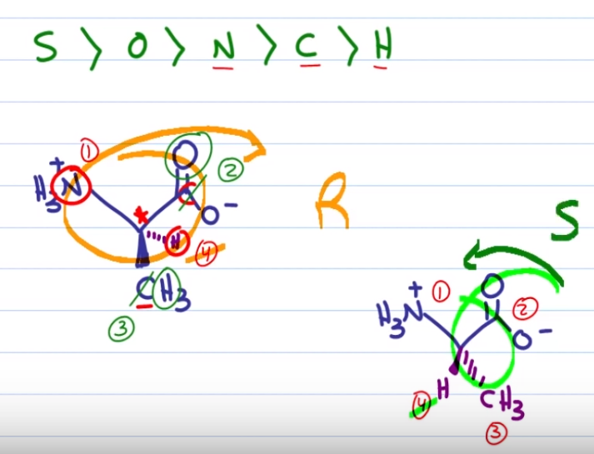

(R-S using CIP)

* Note that glycine does not have a chiral carbon so R-S cannot be assigned

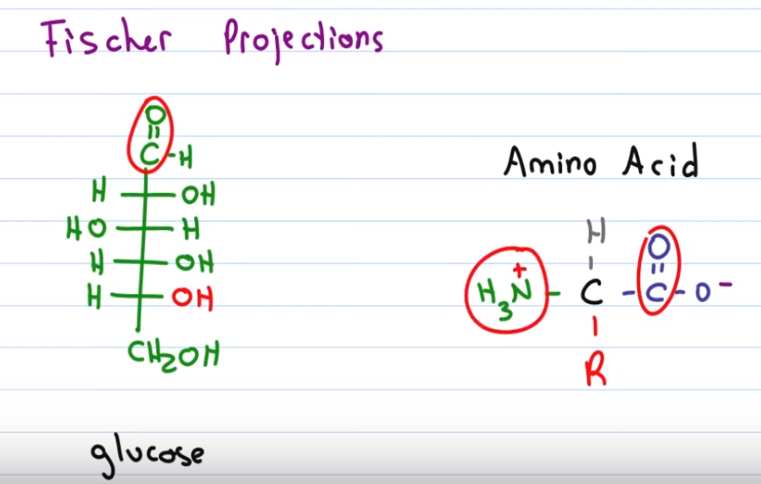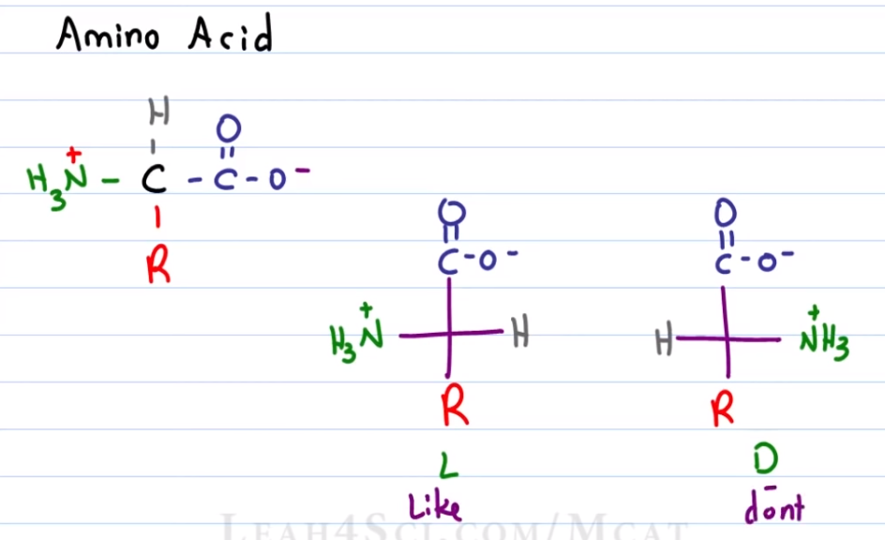

(L-D using Fischer Projections)

* C=O must always be on top
* For carbohydrate:
  + If the lowest O-H group (in red) is to the right, then it’s D-sugar
  + If it is to the left, then it’s L-sugar
* For amino acid:
  + If the amino group (in green) is to the right, then it’s D-amino acid
  + If it is to the left, then it is **L**-amino acid (we **LIKE** this → more common)

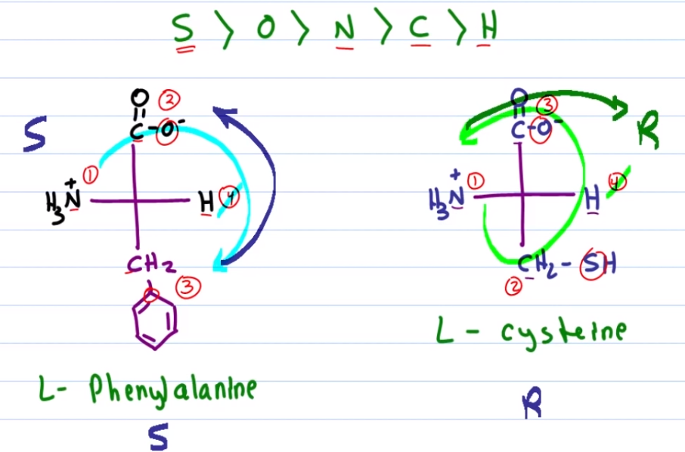

(Converting L-D to R-S configuration)

* As this is a Fischer projection (think of it like a man wearing a bowtie), the horizontal lines are pointing out of the page so H is pointing out of the page, meaning that we need to reverse the R-S configuration after assignment (if we were to treat H to be of lowest priority, i.e. pointing into the page)
* Note that L-cysteine is the only amino acid with R configuration due to the sulfur atom in that particular position